Xiaomi Negative

Topics =4

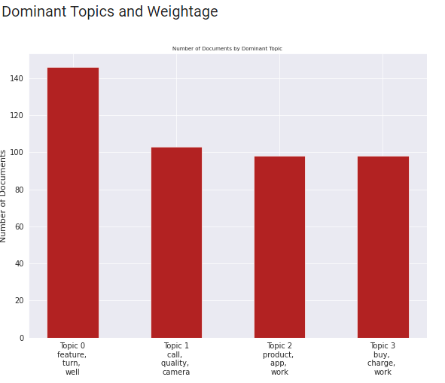

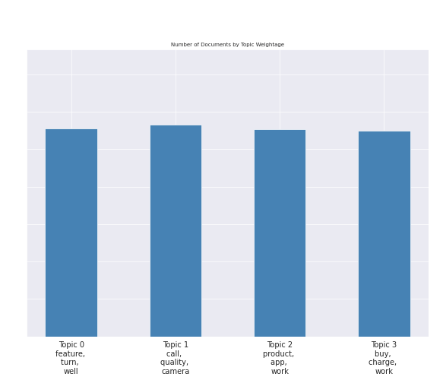

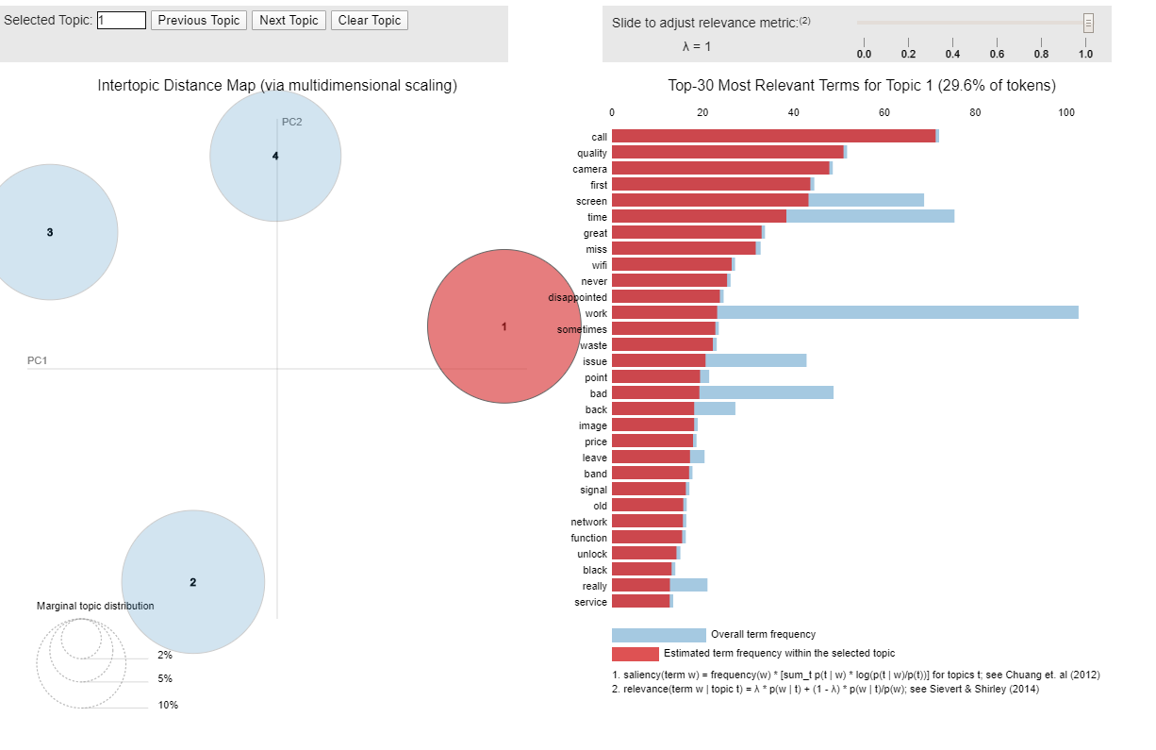

Call quality, camera and screen is an issue , not connecting to wifi?- topic 1

Features are bad, Bad battery – topic 4 – about overall experience?

Topic 3 about the product – storage issue , case issue , sd card , product is slow

Topic 2 – more about how the product is bought, received , returned

Apps not working properly?

Major issues concerning Xiaomi– Call drop, Charging(battery drain),camera and picture quality , different features - gimmicks

Xiaomi positive

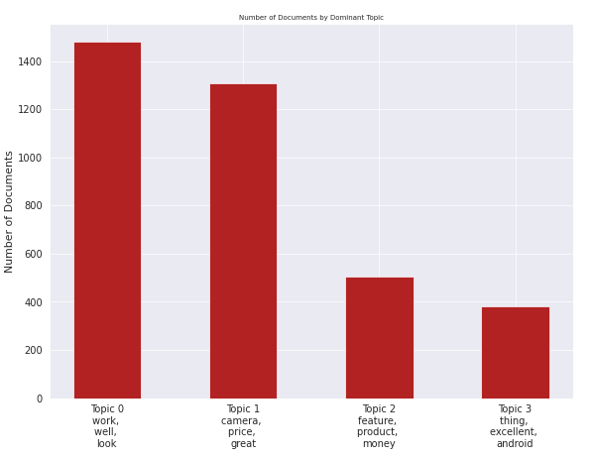

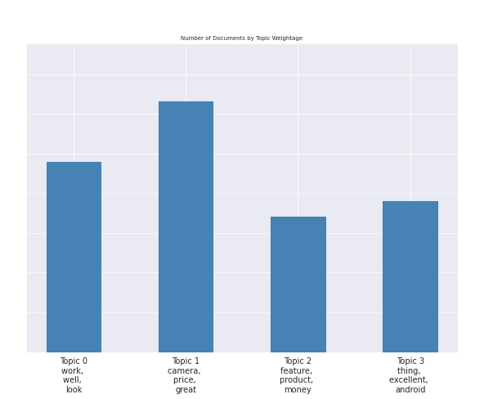

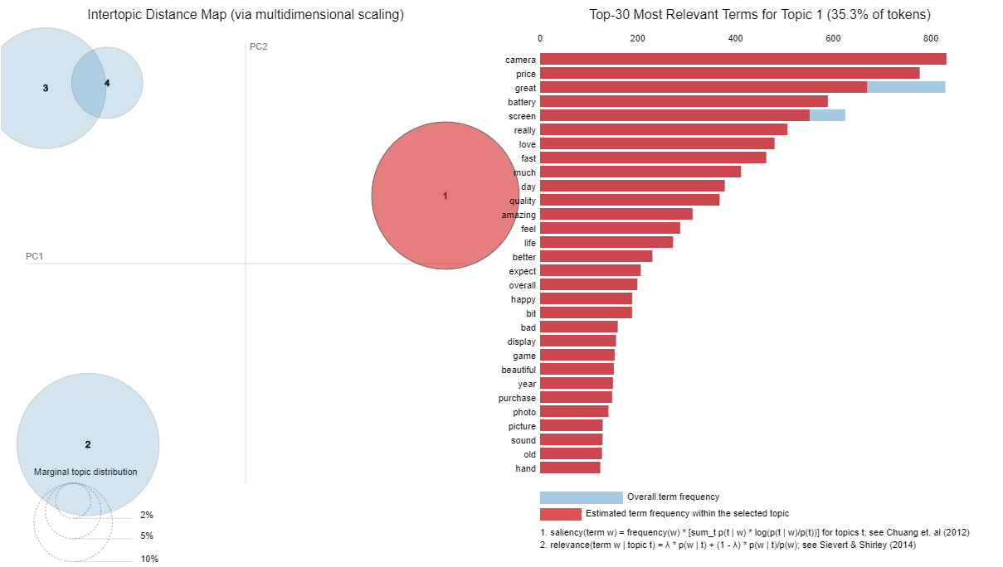

Topic 1: price points , battery , screen , fast

Topic 2: works well, performance ,cheap

Topic 3: excellent android device, worth the buy,video

Topic 4: money and value , solid device , cost effective , gaming exp, headphones

Best thing about Xiaomi : Cost ; The phones are highly valuable . Excellent android device which provides excellent value for the money spent.